红字：总
黄字：该页正文内容标题
黑字：正文内容
黑字：下划线黑字添加超链接（点击链接下载文件）
（PS：“（click to download）”这个文字保留在页面）

Parts
Overview
- Where we found the parts?
- After literature research, we selected two enzymes to create the engineered bacteria: PEP (poly endopeptidase), which has more mature research support, and a more novel enzyme protein (Fvp , gluten enzyme from Flammulina velutipes);
- After a brief background investigation, we chose to use pasr promoter and NO sensor system to control the expression of the adhesion protein. This can help our bacteria to stay in the gut longer and to control the secretion of enzymes;
- We used the most common GFP as one of the reporter proteins; meanwhile we used a much brighter red fluroscence protein, mSandy, as another reporter protein

- Brief introduction about the designed system
- Casuple module (The use of special capsule to protect the engineered bacteria)
  - For example, biocompatibility and digestive enzyme resistance NPA2 coacervate materials, or some commonly enteric-coated capsule materials on the market (methyl methacrylate-acrylic acid copolymer, acrylic resin L/S type, cellulose acetate phthalate (CAP), hydroxypropyl methylcellulose phthalate (HPMCP), polyvinyl phthalate (PVAP), sodium alendronate enteric-coated capsules, etc.). The wrap material helps bacteria safely enter the intestines:
  - Avoid the influence of drugs by gastric pH and enzymes, and improve drug stability;
  - Directed delivery of drugs to the intestine, forming a homogeneous hyperdispersible system in the intestine, exerting local or systemic therapeutic effects;
  - Reduce the side effects of nausea and vomiting caused by the stimulation of the gastric mucosa by drugs, thereby reducing the discomfort of patients;
  - Improve the bioavailability of drugs, etc
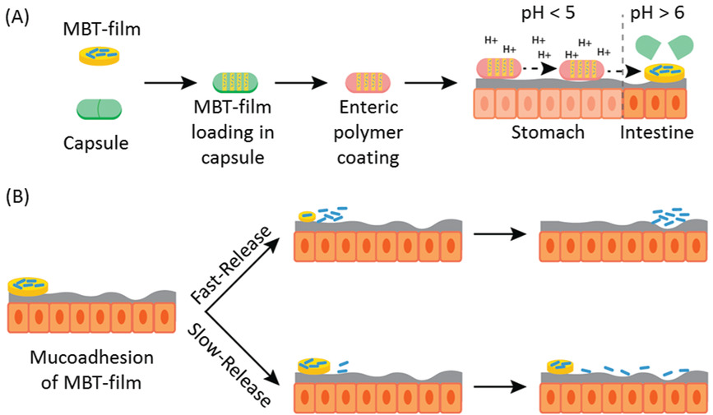
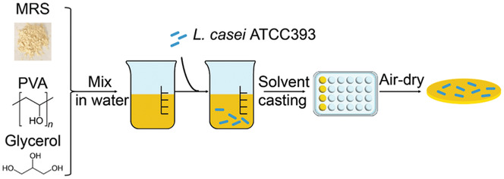
Figure 2.1.1 Schematic diagram of the envisioned MBT-film delivery system. A) Microbes are first encapsulated with storage excipients in MBT-films followed by encapsulation into oral capsules with enteric coatings. After oral administration, the capsules pass through stomach, dissolve, and release MBT-films in the intestines. B) Building on these existing advantages of capsules, MBT-films can be engineered for mucoadhesion and tunable release for modifying the spatiotemporal distribution of the MBT along the intestines.

- Adhesion module (increase the affinity of the bacteria to attach on intestine)
When the bacteria leave the stomach and enter the intestine, the bacteria begin to express adhesion proteins to help them adhere to the small intestine. Ideally, our engineered bacteria achieve intestinal colonization.

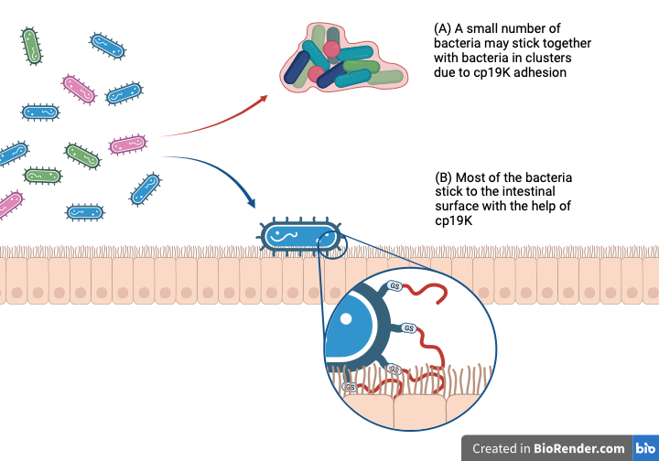
In this module, based on the pH change within the gastrointestinal tract, we will use a pH sensor (Pasr promoter) to control the expression of adhesion proteins. When the pH value is low (probably around 5 to 5.5), the protein will be expressed efficiently. The adhesion protein, cp19k, will allow the bacteria attach on the intestine epithelial cells.

Figure 2.1.2 Bacteria attach to the surface of the intestine with the help of cp19k [2][3]. Although it is inevitable that some bacteria could attach into a large lump – but they are easy to be washed away and leave the intestine. Here, we propose to increase the chance of our engineered bacteria to survive in intestine by controlling the spatiotemporal expression of cp19k. The expression of this adhesion protein could make the bacteria “ sticky”. Hence, we can reduce the number of bacteria in the therapy and enhance the production of the enzymes in each treatment.

- Release module

When the bacteria enter the intestine and a rise in NO concentration is detected because of the celiac disease. By the NO sensor system, this will induce the expression of our target enzymes (PEP and Fvp). These two enzymes could help patients to break down amino acid residues (gluten that has not been completely broken down) that causes the immune response. (please add why the enzymes can be released from the bacteria)
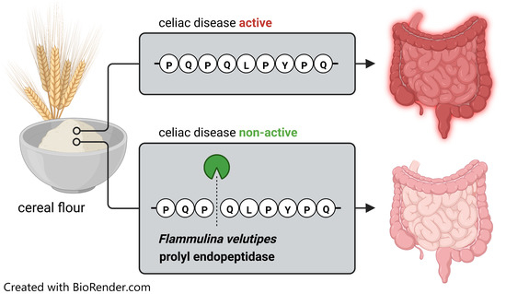

Figure 2.1.3 For celiac disease caused by 33-mer residues (from cereal proteins) becoming antigens, we hydrolyze 33-mer with Fvp gluten enzyme (and PEP gluten enzyme) to make it lose its immunogenicity, so as to achieve therapeutic purposes

Regarding to the NO sensor, it includes a regulator part plus NO promoter. Only when the NO concentration higher than the threshold level , the binding of NO to the regulator will inhibit its bind to the NO promoter, thereby initiating the expression of gluten enzyme [4][5].

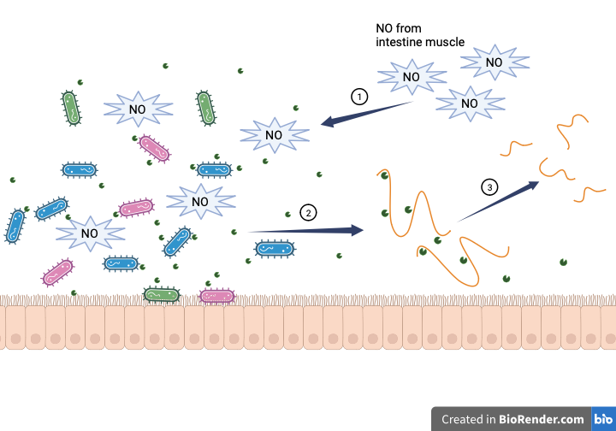

Figure 2.1.4 Step ①: NO induces engineering bacteria to express gluten enzymes; step ②: Engineering bacteria secrete gluten enzymes; step ③: 33-mer is broken down by enzymes into small fragments that are not immunogenic.

- Safety control
In this module, we theoretically envision the addition of a safety switch for colony quenching, which expresses when the bacterial concentration is too high and plays the role of inhibiting and killing the flora.

Table for details:
Adhesion Module
Name (BBa_K4716000-BBa_4716999) | Nickname | Parts type (Basic or composit) | Description | Length
（BBa_K4716000) | Pasr | Promoter | In the Gluten Enzymatic Intestinal Guardians project, we want to colonise the intestinal microbiota is located in the duodenum region, and because of its specific pH of this environment is skewed towards acidic. Therefore, we used the Pasr promoter as an initiating element for control of the adhesion protein surface display.  The Pasr promoter, with a length of 140 bp, it is responsive promoter native to E. coli and it induces transcription in relatively acidic conditions (pH 5-6). | 140 bp
（BBa_K4716001) | cp19k | Protein (for adhesion) | The 19 kDa cement protein (cp19k), was extracted from barnacle and have an adhesion effect without the need of post-modification. For barnacles, the source of cp19k, their role is to help them anchor to the bottom of reefs and ships in order to maintain their position against ocean currents, which means cp19k is a very powerful bio-adhesive material in nature. In our project, we used Pasr promoter (BBa_K4716000) as the initiator of the adhesion module, and display it on E. coli DH5-alpha membrane through CsgA domain (BBa_K4716002). We propose the adhesion properties of cp19k and could be a better option for small intestinal surface adhesion protein. | 519 bp
（BBa_K4716002) | CsgA | Protein | As an E. coli curli protein, CsgA not only accelerates amyloid self-assembly but also serves as a platform for displaying recombinant proteins on the surface of E. coli. (in our project, the recombinant proteins are the adhesive protein system of cp19k and mefp5) to create a hierarchically organized network of amyloid nanofibers. | 393 bp
（BBa_K4716003) | mefp5 | Protein (for adhesion) | Mytilus edulis foot protein-5 (mefp5) is found in the mussel Mytilus edulis byssal sticky plaque. When Dopa concentration is high, it will led to Mefp-5 become adhesive. | 294 bp
（BBa_K4716004) | Perpa | Protein | Perhydrolase  The sequence was taken from NCBI data base and was derived from Pseudomonas aeruginosa. Our adhesive system performs better because to epoxidation. When there are suitable acceptor molecules present, chloroperoxidase can use the ions chloride, bromide, and iodide to catalyse the production of a carbon-halogen bond to optimize the adhesive effect of mefp5（BBa_K4716003). | 825 bp
（BBa_K4716005) | mSandy [9] | Report protein | mSandy is a red fluorescent protein (RFP) and in this project we use this kind of RFP in our adhesion module as reporter protein, which we get the information from Legault, S. et al.’s literature that it is a little brighter than mCherry and may have better effect of fluorescence for us to observe the target bacteria. Import from Addgene: pET-29b(+)-mSandy2 (plasmid #177760) | 732 bp
（BBa_K4716006) | GS linker | Linker protein | In order to minimize the possibility that the obstruction of the folding because of the sterically effect of different domains [adhesive protein (cp19k and mefp-5), reporter protein (mSandy2) and fusion protein (CsgA) for surface display], we use the GS linker in our adhesion module’s plasmids as a “bridge” to prevent the creation of secondary structures and cause the function loss. | 30 bp
（BBa_K4716007) | pSB1C3-Pasr-CsgA-Perpa-mefp5-mSandy | Plasmid | To control our gene expression, we used a Pasr promoter (BBa_K4716000) which is the pH-responsive promoter to induce transcription in human duodenum region’s relatively acidic environment (pH 5~6).  This plasmid also included a RBS (BBa_B0034) is the ribosome binding site, CsgA-Perpa-mefp5 is our target gene, the mSandy is the reporter gene and the double terminator (BBa_B0015) is the terminator we use in this circuit, BioBrick prefix and BioBrick suffix are presented at the beginning and end of the whole insert gene, respectively.  In the opposite direction, the cat promoter controls the CmR gene which is the antibiotic selection marker, carrying chloramphenicaol resistance gene. Followed by Lambda T0 terminator, there is also a replication origin for the whole plasmid. | 4701 bp
（BBa_K4716008) | pSB1C3-J23119-CsgA-Perpa-mefp5-mSandy | Plasmid | As the control plasmid in non-acidic environment for expressing mefp-5 adhesive protein with the backbone of PSB1C3, on the direction for our target gene we use the constitutive promoter J23119 (BBa_J23119), RBS (BBa_B0034) is the ribosome binding site. | 4596 bp
（BBa_K4716009) | pSB1C3-Pasr-CsgA-cp19k-mSandy | Plasmid | Similar to the pSB1C3-Pasr-CsgA-Perpa-mefp5-mSandy (BBa_K4716007), but the adhesion protein was changed to cp19k. | 4071 bp
（BBa_K4716010) | pSB1C3-J23119-CsgA-cp19k-mSandy | Plasmid | Control plasmid for the CsgA-cp19k protein. Similar to the pSB1C3-J23119-CsgA-Perpa-mefp5-mSandy（BBa_K4716008) by replacing the mefp5 sequence to cp19k. | 3996 bp
（BBa_K4716011) | pSB1C3-J23119-mSandy | Plasmid | Control plasmid that without any adhesion protein, with the J23119 promoter. | 3021 bp
（BBa_K4716012) | pSB1C3-Pasr-mSandy | Plasmid | Control plasmid that without any adhesion protein, with the pH sensitive promoter (Pasr).

Release Module
Name (BBa_K4716000-BBa_4716999) | Nickname | Parts type (Basic or composit) | Description | Length
（BBa_K4716999) | ProA | Promoter (for regulator) | Initiates DNA transcription expressing NorR protein.  The relatively weaker constitutive promoter for expressing NO-binding protein NorR (BBa_K4716998), When we use this weaker promoter for NorR the sensitive of NO sensor will be higher that lower the threshold for our NO sensor to be triggered by nitric oxide for prolyl endopeptidase expression in an inflammatory-like environment. | 166bp
（BBa_K4716998) | NorR | Regulator | NorR has two very important functions, one is that it can bind to the promoter PnorV (BBa_K4716997) on DNA, and the other is that it can also bind more preferentially to NO in the presence of nitric oxide in the environment. NorR binds to DNA and inhibits transcription initiation; When NO molecules are present in the environment，NorR exposes its AAA+ ATPase domai，nnbinding to DNA molecule (PnorV promoter) will release its inhibition of downstream gene expression, allowing genes downstream of the PnorV promoter to be transcribed and expressed. In our project, NorR will be mediated by the ProA promoter (BBa_K4716999) to repress proline endopeptidase (BBa_K4716996 and BBa_K4716995) expression downstream of the PnorV promoter. | 1515 bp
（BBa_K4716997) | PnorV | Promoter (NO sensor part) | The PnorV promoter is a nitric oxide-inducible, σ-dependent promoter that is controlled by NorR. Repression of this promoter by NorR contact when NO molecules are present in the environment allows it to initiate expression of downstream genes. | 256 bp
（BBa_K4716996) | Fvp-p [6][7] | Protein (for enzyme) | Fvp is a prolyl endopeptidase gluten breaking enzyme from Enokitake  (Flammulina  velutipes), which can digest the 33-mer toxic peptide of gluten for celiac disease patients that cannot be completely broken down in the intestine more efficiently. We expect it to be expressed in E. coli and secrete the enzyme outside the gut microbiota. | 1578 bp
（BBa_K4716995) | PEP[4][8] | Protein (for enzyme) | PEP is also a prolyl endopeptidase and a gluten enzyme which is derived from Stenotrophomonas maltophilia. It has been used as a study of oral enzyme therapy for consumption in celiac disease patients. | 1740 bp
（BBa_K4716994) | NSP4 | Signal peptide | The Novel Signal Peptide 4 (NSP4) has a function through the type II secretion system in E. coli. As it is binding with our two kinds prolyl endopeptidase protein, it can transport our enzyme across the two-layer structure of E. coli DH5-alpha membranes and release our enzymes from our engineered bacteria. | 60 bp
（BBa_K4716993) | sfGFP | Report protein | Superfolder GFP (sfGFP) is a basic (constitutively fluorescent) green fluorescent protein published in 2005, derived from Aequorea victoria. In this module we use the sfGFP to work as the reporter protein of plasmids with J23119 constitutive promoter. | 711 bp
（BBa_K4716992) | pET-NorR-ProA-  PnorV-Fvp-his tag | Plasmid | To control our PnorV regulator gene, there is a constitutive ProA promoter (BBa_K4716999) induce the expression of NorR protein (BBa_K4716998). On the opposite direction for our gene expression are the PnorV promoter which can bind with NorR protein when there is no nitric oxygen in environment, RBS (BBa_B0034) which is the ribosome binding site, our target gene NSP4-Fvp, 6xhis tag as our antibody binding site in our protein analysis process and the double terminator (BBa_B0015) is the terminator. On our backbone pET, the resistant gene of ampicillin has the function for screening the successful transformed bacteria. Near the gene of Rop protein there is also a replication origin for the whole vector. | 9451 bp
（BBa_K4716991) | pET-NorR-ProA-  PnorV-PEP-his tag | Plasmid | Similar to the pET-NorR-ProA-  PnorV-Fvp-his tag (BBa_K4716992), but replaced the enzyme by the PEP sequence. | 9613 bp
（BBa_K4716990) | pET-J23119-Fvp-sfGFP | Plasmid | A constitutively expression vector, that express the Fvp. In this plasmid, the NO sensor system was removed and used the J23119 promoter. | 8168 bp
（BBa_K4716989) | pET-J23119-PEP-  sfGFP | Plasmid | Similar to the pET-J23119-Fvp-sfGFP (BBa_K4716990), but replaced the enzyme by PEP sequence. | 8330 bp
（BBa_K4716988) | pET-J23119-sfGFP | Plasmid | As the control group plasmid in enzymatic release module, on the direction for our target gene we use the constitutive promoter J23119 (BBa_J23119), RBS (BBa_B0034) is the ribosome binding site, sfGFP gene is our fluorescent reporter gene, double terminator (BBa_B0015) is the terminator. On our backbone pET, the resistant gene of ampicilin has the function for screening the successful transformed bacteria. Near the gene of Rop protein there is also an pBR332 replication origin for the whole vector. | 6503 bp
（BBa_K4716987) | Fvp-his tag | Protein | Fvp plus 6xHis tag. | 1617 bp
（BBa_K4716986) | PEP-his tag | Protein | PEP plus 6xHis tag. | 1779 bp

Download the plasmids maps (click here to download)

References:
- Alvarez-Sieiro, P., Martin, M. C., Redruello, B., Del Rio, B., Ladero, V., Palanski, B. A., ... & Alvarez, M. A. (2014). Generation of food-grade recombinant Lactobacillus casei delivering Myxococcus xanthus prolyl endopeptidase. Applied microbiology and biotechnology, 98, 6689-6700.
https://doi.org/10.1007/s00253-014-5730-7
- Tilbury, M. A., McCarthy, S., Domagalska, M., Ederth, T., Power, A. M., & Wall, J. G. (2019). The expression and characterization of recombinant cp19k barnacle cement protein from Pollicipes pollicipes. Philosophical Transactions of the Royal Society B, 374(1784), 20190205.
https://doi.org/10.1098/rstb.2019.0205
- Li, F., Ye, L., Zhang, L., Li, X., Liu, X., Zhu, J., ... & Yan, J. (2022). Design of a genetically programmed barnacle-curli inspired living-cell bioadhesive. Materials Today Bio, 14, 100256.
https://doi.org/10.1016/j.mtbio.2022.100256
- Sun, H., Yang, J., & Song, H. (2020). Engineering mycobacteria artificial promoters and ribosomal binding sites for enhanced sterol production. Biochemical Engineering Journal, 162, 107739.
https://doi.org/10.1016/j.bej.2020.107739
- Chen, X. J., Wang, B., Thompson, I. P., & Huang, W. E. (2021). Rational design and characterization of nitric oxide biosensors in E. coli Nissle 1917 and Mini SimCells. ACS Synthetic Biology, 10(10), 2566-2578.
https://doi.org/10.1021/acssynbio.1c00223
- Gass, J., & Khosla, C. (2007). Prolyl endopeptidases. Cellular and molecular life sciences, 64, 345-355.
https://doi.org/10.1007/s00018-006-6317-y
- Ersoy, F., Beinhorn, P., Schalk, K., Scherf, K. A., Berger, R. G., & Krings, U. (2023). A Prolyl Endopeptidase from Flammulina velutipes Degrades Celiac Disease-Inducing Peptides in Grain Flour Samples. Catalysts, 13(1), 158.
https://doi.org/10.3390/catal13010158
- Stepniak, D., Spaenij-Dekking, L., Mitea, C., Moester, M., de Ru, A., Baak-Pablo, R., ... & Koning, F. (2006). Highly efficient gluten degradation with a newly identified prolyl endoprotease: implications for celiac disease. American Journal of Physiology-Gastrointestinal and Liver Physiology.
https://doi.org/10.1152/ajpgi.00034.2006
- Legault, S., Fraser-Halberg, D. P., McAnelly, R. L., Eason, M. G., Thompson, M. C., & Chica, R. A. (2022). Generation of bright monomeric red fluorescent proteins via computational design of enhanced chromophore packing. Chemical Science, 13(5), 1408-1418.
https://doi.org/10.1039/D1SC05088E
- Zhao, P., Xia, X., Xu, X., Leung, K. K. C., Rai, A., Deng, Y., ... & Bian, L. (2021). Nanoparticle-assembled bioadhesive coacervate coating with prolonged gastrointestinal retention for inflammatory bowel disease therapy. Nature Communications, 12(1), 7162.
https://doi.org/10.1038/s41467-021-27463-6

